Insurance Coverage and Fertility-Related Medical Help
  - Evidence from the 2022-2023 National Survey of Family Growth
DATA 400
Individual Mini-Project
Gracie Nguyen

1. Introduction
Access to reproductive healthcare is an important public health issue in the United States. For individuals who experience difficulty becoming pregnant, medical services can provide support through fertility evaluations, consultations, and treatments. However, access to these services may differ depending on health insurance coverage and socioeconomic characteristics.
Health insurance may influence the affordability of fertility-related medical care, but insurance groups also differ in other ways. For example, individuals with private insurance may have higher incomes, more education, or different age distributions than individuals covered by Medicaid. These characteristics may also be associated with whether someone receives fertility-related medical help. Therefore, simply comparing the percentage of people receiving help across insurance groups may not provide a complete understanding of the relationship.
This project examines the following research question:
Is current insurance type associated with ever receiving medical help to become pregnant, after accounting for age, income, and education?
The analysis uses nationally representative survey data from the 2022-2023 National Survey of Family Growth (NSFG). It explores differences in medical help receipt across insurance groups and socioeconomic characteristics, including comparisons within similar income categories. Survey-weighted logistic regression is then used to examine whether insurance differences remain after statistical adjustment and whether the results are consistent across different specifications of age.
The findings may be relevant to reproductive-health researchers, healthcare advocates, and policymakers interested in understanding differences in fertility-related medical care.

2. Data and Methods

2.1 Data Source and Sample
This study uses the 2022-2023 NSFG Female Respondent Public-Use File, provided by the Centers for Disease Control and Prevention (CDC). The survey collects information on fertility, reproductive health, and demographic and socioeconomic characteristics.
The original dataset contains 5,586 respondents. After excluding missing or invalid responses for the variables used in the analysis, the final sample includes 5,195 respondents. Survey weights, strata, and clusters are incorporated to account for the complex survey design.

2.2 Variables
The outcome variable is whether a respondent has ever received medical help to become pregnant (HLPPRG), coded as 1 for yes and 0 for no.
The main explanatory variable is current insurance coverage (CURR_INS), divided into four categories:
- Private insurance/Medi-Gap
- Medicaid/CHIP/state coverage
- Medicare/military/other government coverage
- Single-service/IHS/uninsured
Private insurance/Medi-Gap is the reference category.
The control variables include age (AGER), income relative to the poverty threshold (POVERTY), and education (HIEDUC). For descriptive analysis, income is divided into four categories: ≤100%, 101-200%, 201-400%, and >400% of the poverty threshold. Education is grouped into four levels: less than high school, high school/GED, some college/associate degree, and bachelor's degree or higher.

2.3 Analytical Approach
The analysis begins with survey-weighted descriptive statistics and visualizations to examine medical help receipt across insurance, age, income, and education groups. It also compares respondent characteristics across insurance categories.
Next, medical help receipt is compared between private and Medicaid respondents within four income groups. This Insurance × Income comparison examines whether the observed insurance gap varies across income levels.
Finally, survey-weighted logistic regression is used to estimate the association between insurance coverage and medical help receipt while controlling for age, income, and education. Two specifications are compared: one with a linear age term and another including age squared to allow for a nonlinear relationship.
Results are reported using weighted percentages, odds ratios, and 95% confidence intervals. The analysis identifies associations rather than causal effects.

3. Exploratory Data Analysis

3.1 Medical Help Receipt by Insurance Coverage
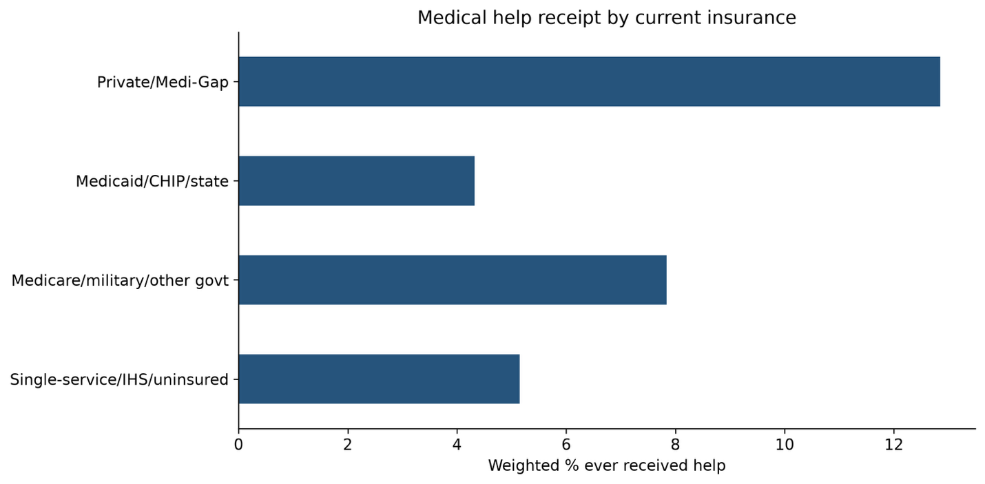
Figure 1: Weighted Medical Help Receipt by Insurance Coverage
Respondents with private insurance have the highest reported rate of receiving fertility-related medical help, at approximately 12.9%, compared with 4.3% among Medicaid respondents. This represents a difference of approximately 8.5 percentage points.
The other insurance groups also report lower rates than privately insured respondents. However, these percentages do not account for differences in respondent characteristics.

3.2 Differences in Respondent Characteristics
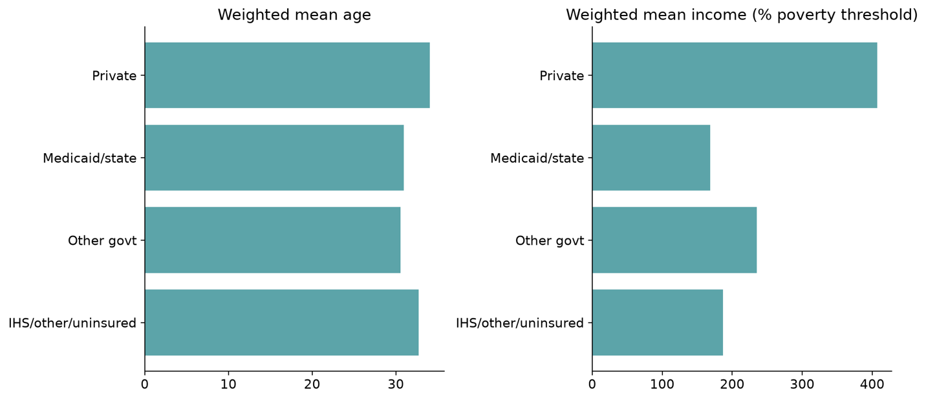
Figure 2: Weighted Mean Age and Income by Insurance
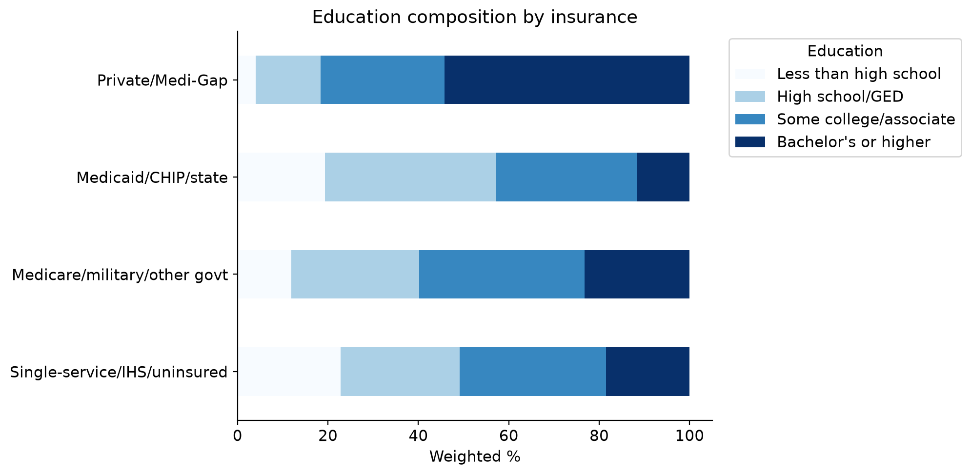
Figure 3: Education Composition by Insurance
Private and Medicaid respondents differ substantially in age, income, and education. Privately insured respondents are older on average (34.1 vs. 30.9 years) and have higher mean incomes relative to the poverty threshold (407% vs. 168%). They are also more likely to hold a bachelor's degree or higher (54.2% vs. 11.7%).
These differences suggest that demographic and socioeconomic characteristics may contribute to the observed insurance gap and should be considered in the regression analysis.

3.3 Medical Help Receipt by Age, Income, and Education
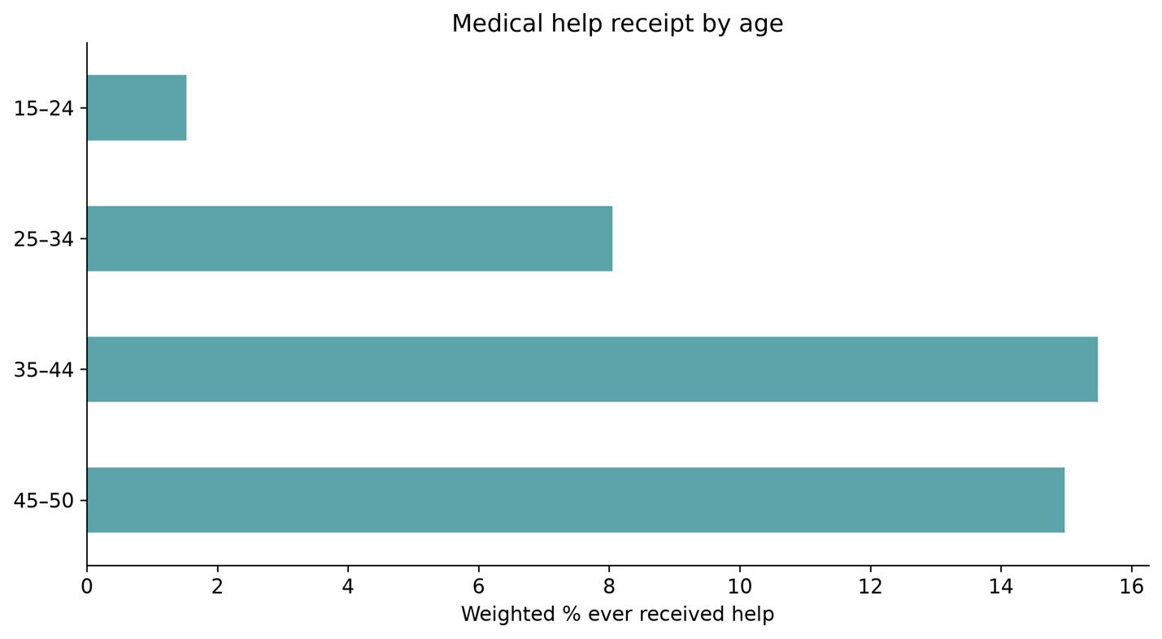
Figure 4: Medical Help Receipt by Age
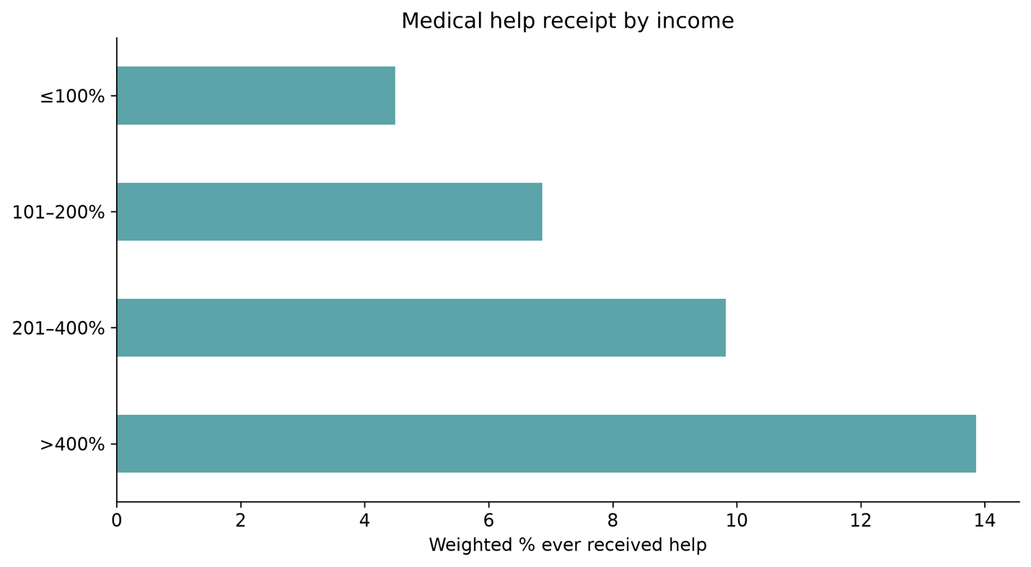
Figure 5: Medical Help Receipt by Income
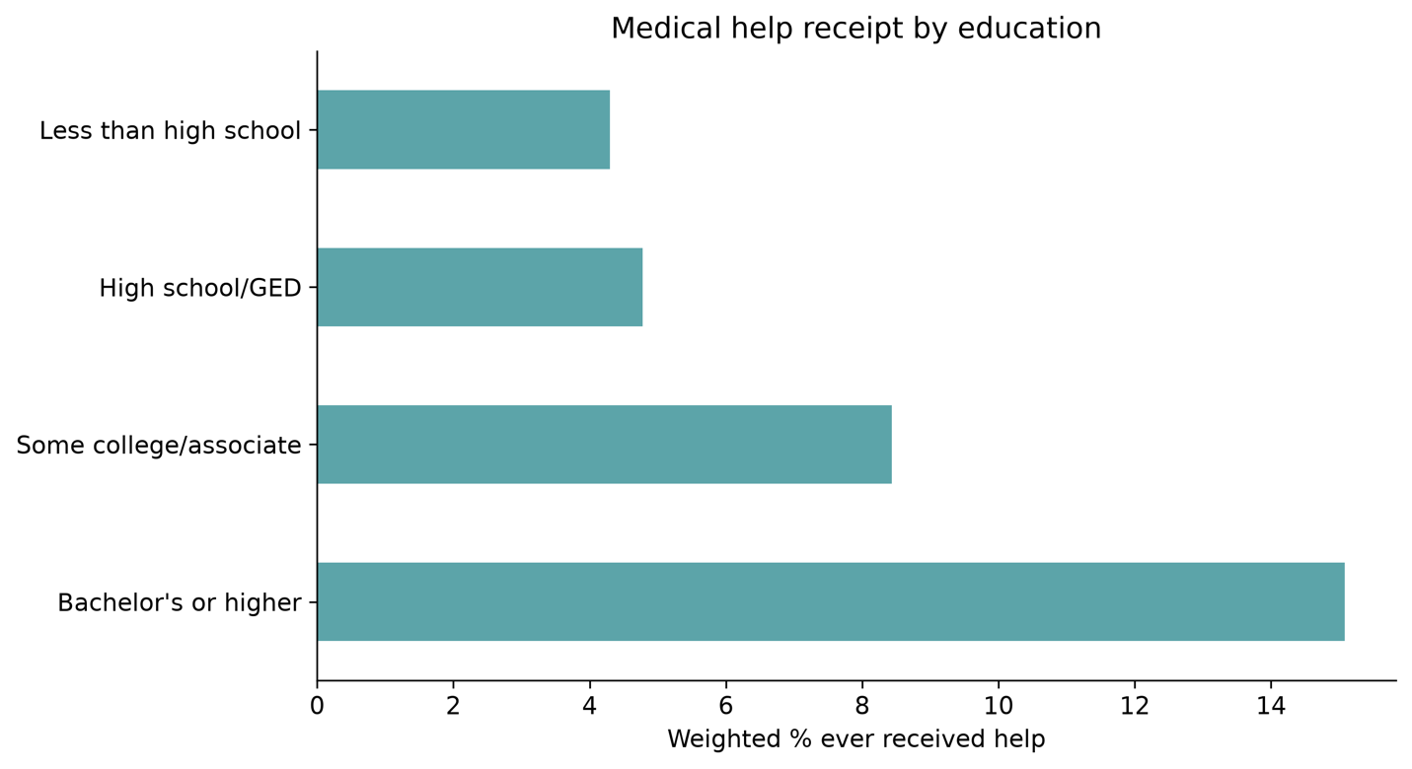
Figure 6: Medical Help Receipt by Education
Medical help receipt increases across several demographic and socioeconomic categories.
By age, approximately 1.5% of respondents aged 15-24 report receiving help, compared with 15.5% among respondents aged 35-44. By income, the reported rate increases from approximately 4.5% among respondents at or below 100% of the poverty threshold to 13.9% among those above 400%. A similar pattern appears across education levels. Approximately 4.3% of respondents with less than a high school education report receiving help, compared with 15.1% of respondents with a bachelor's degree or higher.
These patterns show why age, income, and education are relevant to the relationship between insurance coverage and medical help receipt.

3.4 Insurance Differences Across Age Groups
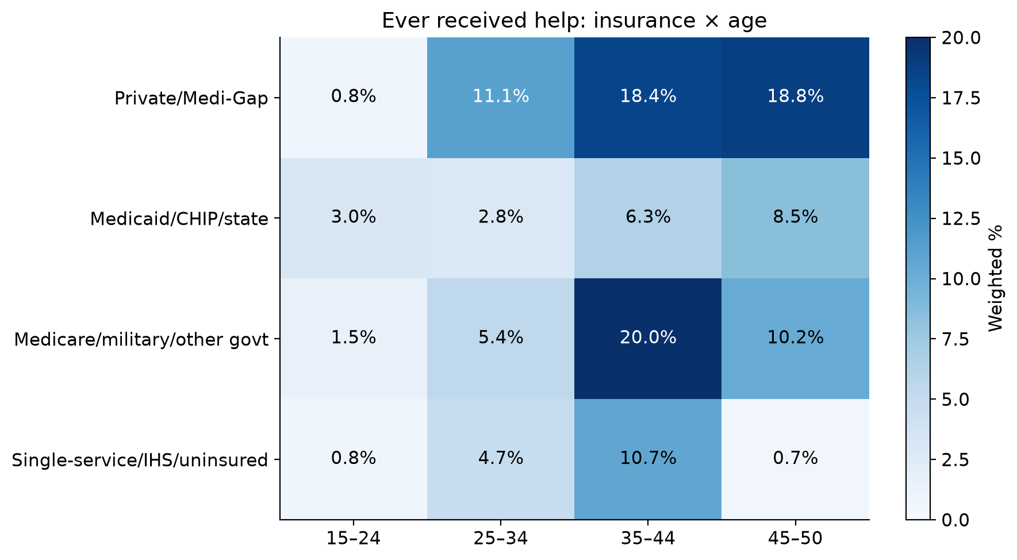
Figure 7: Insurance × Age Heatmap
The insurance-by-age comparison shows that private insurance is associated with higher reported medical help receipt than Medicaid among respondents aged 25 and older.
For example, among respondents aged 25-34, approximately 11.1% of privately insured respondents report receiving help, compared with 2.8% of Medicaid respondents. Among respondents aged 35-44, the corresponding rates are 18.4% and 6.3%.
The pattern differs among respondents aged 15-24, where Medicaid respondents have a higher reported rate. However, some age-insurance groups have relatively few observations, so these comparisons should be interpreted cautiously.
Overall, the results suggest that differences in age composition alone may not fully explain the observed insurance gap.

3.5 Insurance Differences Across Income Groups
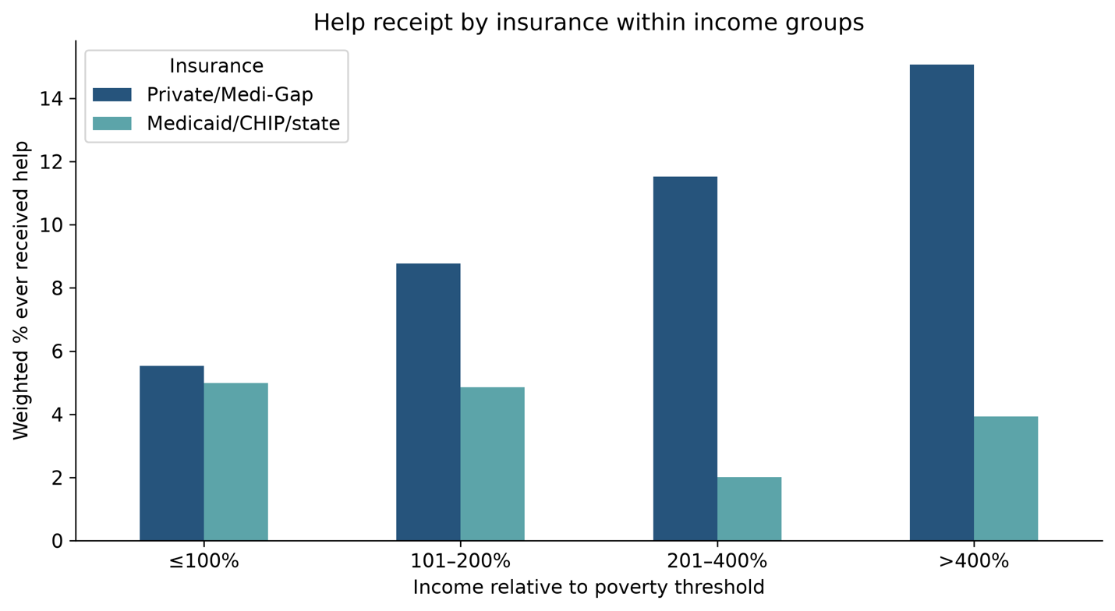
Figure 8: Insurance × Income Grouped Chart
To examine whether insurance differences persist within similar income categories, medical help receipt is compared between private and Medicaid respondents across four income groups.
Among respondents at or below 100% of the poverty threshold, private and Medicaid respondents report similar rates of receiving medical help: 5.5% and 5.0%, respectively.
However, the observed gap becomes larger at higher income levels. For respondents between 201% and 400% of the poverty threshold, the rates are 11.5% for private insurance and 2.0% for Medicaid. Among respondents above 400%, the rates are 15.1% and 3.9%.
These findings suggest that the descriptive insurance gap varies across income categories. However, some Medicaid income groups have few respondents reporting medical help, particularly at higher income levels. The comparisons are descriptive and do not establish statistically significant differences between income groups.

4. Survey-Weighted Logistic Regression

4.1 Adjusted Insurance Associations
Survey-weighted logistic regression is used to examine whether insurance differences remain after accounting for age, income, and education.
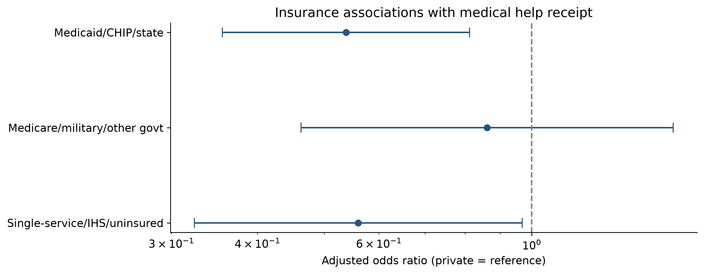
Figure 9: Adjusted Odds Ratios by Insurance Coverage
Insurance compared with private | Adjusted odds ratio | 95% CI
Medicaid/CHIP/state | 0.54 | 0.36 - 0.81
Medicare/military/other government | 0.86 | 0.46 - 1.60
Single-service/IHS/uninsured | 0.56 | 0.32 - 0.97
Table 1. Adjusted Odds Ratios for Fertility-Related Medical Help by Insurance Coverage
Medicaid respondents have an adjusted odds ratio of 0.54 compared with privately insured respondents. This corresponds to approximately 46% lower estimated odds of reporting fertility-related medical help after accounting for age, income, and education. The confidence interval does not include 1, indicating a statistically significant association. Respondents in the single-service/IHS/uninsured category also have significantly lower estimated odds, with an adjusted odds ratio of 0.56. For the Medicare/military/other government group, the adjusted odds ratio is 0.86. However, the confidence interval includes 1, so there is insufficient evidence of a difference from private insurance.

4.2 Unadjusted and Adjusted Comparisons
Insurance group | Unadjusted OR | Adjusted OR
Medicaid/CHIP/state | 0.31 | 0.54
Medicare/military/other government | 0.58 | 0.86
Single-service/IHS/uninsured | 0.37 | 0.56
Table 2. Comparison of Unadjusted and Adjusted Odds Ratios by Insurance Coverage
After controlling for age, income, and education, all three insurance odds ratios move closer to 1.
For Medicaid, the odds ratio changes from 0.31 to 0.54. This suggests that differences in demographic and socioeconomic characteristics are relevant to the observed association. However, the Medicaid association remains statistically significant after adjustment.
Because odds ratios can change when predictors are added to a logistic regression, the change should not be interpreted as the exact share of the insurance difference explained by the controls.

4.3 Linear and Nonlinear Age Specifications
The descriptive results suggest that medical help receipt may not have a constant relationship with age. To examine this, the regression model is estimated both with and without an age-squared term.

Insurance group | Linear age OR (95% CI) | Age-squared OR (95% CI)
Medicaid/CHIP/state | 0.54  (0.36 - 0.81) | 0.53  (0.35 - 0.82)
Medicare/military/other government | 0.86  (0.46 - 1.60) | 0.94  (0.50 - 1.79)
Single-service/IHS/uninsured | 0.56  (0.32 - 0.97) | 0.55  (0.32 - 0.96)
Table 3. Comparison of Adjusted Odds Ratios Between Linear and Age-Squared Models
The insurance estimates remain relatively stable after including age squared. For Medicaid, the odds ratio changes only slightly from 0.54 to 0.53, and the association remains statistically significant. The single-service/IHS/uninsured estimate also changes very little. The other government category remains statistically insignificant in both specifications.
Overall, the main insurance findings are consistent across the two age specifications. However, these results alone do not establish that the age-squared model provides a better overall fit.

5. Discussion
The results show a consistent association between insurance coverage and reported fertility-related medical help.
Private insurance respondents report higher rates of receiving help than Medicaid respondents, but the two groups also differ substantially in age, income, and education. After adjusting for these characteristics, Medicaid respondents continue to have significantly lower estimated odds of reporting medical help.
The Insurance × Income comparison provides further context. The private–Medicaid difference is relatively small among the lowest-income respondents but becomes larger at higher income levels. This suggests that the observed insurance gap is not uniform across income categories, although formal statistical testing would be needed to determine whether these differences are significant.
The regression results are also consistent across the linear and age-squared specifications, suggesting that the main insurance associations are not highly sensitive to how age is modeled in this analysis.
These findings are broadly consistent with Eliason et al. (2023), who examined differences in fertility-service use between Medicaid and privately insured individuals in the United States. However, the studies use different outcome definitions and populations, so their estimates are not directly comparable.
Together, the findings suggest that insurance coverage is associated with reported fertility-related medical help, even after accounting for selected demographic and socioeconomic characteristics.

6. Limitations
Several limitations should be considered.
First, the outcome measures whether respondents have **ever** received fertility-related medical help, while insurance coverage is measured at the time of the survey. Respondents may have had different insurance coverage when they received care.
Second, the analysis does not fully account for differences in fertility needs or intentions. Some respondents may never have attempted to become pregnant or needed fertility-related services.
Third, the study uses observational, self-reported data. Although the model controls for age, income, and education, other unmeasured factors may influence both insurance coverage and medical help receipt. Therefore, the results cannot establish causation.
Fourth, some insurance-income groups have small numbers of respondents reporting medical help, making their weighted percentages less precise.
Finally, the insurance categories combine different coverage arrangements, and the regression comparison does not include a formal model-fit test.

7. Conclusion
This project examined the relationship between current insurance coverage and ever receiving fertility-related medical help using the 2022–2023 National Survey of Family Growth.
The descriptive results show that 12.9% of privately insured respondents report receiving medical help, compared with 4.3% of Medicaid respondents. After accounting for age, income, and education, Medicaid respondents continue to have significantly lower estimated odds of reporting help.
The Insurance × Income comparison shows that the observed gap is relatively small among the lowest-income respondents but larger in higher-income categories. The regression findings also remain consistent when age squared is included in the model.
Overall, the results suggest that insurance coverage is associated with fertility-related medical help receipt, and the observed differences are not fully accounted for by age, income, and education.
Future research could examine insurance coverage at the time care was received, fertility needs and intentions, and whether insurance differences vary significantly across income levels.

References
National Center for Health Statistics. National Survey of Family Growth, 2022-2023.
Public use data file and documentation. http://www.cdc.gov/nchs/nsfg/nsfg-2022-2023-puf.htm
Eliason, E. L., Thoma, M. E., & Steenland, M. W. (2023). Differences in use of fertility treatment between people with Medicaid and private health insurance coverage in the United States. Women's Health Issues, 33(4), 367-373.

